SALES PERFORMANCE ANALYSIS DOCUMENTATION
PREPARED BY EZAKA LINDA CHINYERE
SOURCE: FROM THE COMPANY
DATE: 06-10-2026
Analysis of Frozen Dessert Sales Across Regions, Products and Salespeople, 2013–2015

Project Documentation
Tool: Microsoft Excel (Excel Table, PivotTables, PivotCharts and Slicers)
Source file: EXCEL_DATA ANALYSIS PROJECT.xlsx

Contents
1. Executive Summary
2. Statement of the Problem
3. Objectives
4. Dataset Description
5. Data Cleaning
6. Data Preparation
7. Data Analysis
8. Dashboard
9. Findings
10. Recommendations
11. Limitations
12. Conclusion
Executive Summary

This project turns three years of order-level sales records into an interactive Excel dashboard that management can use to see, at a glance, how the business is performing. The dataset covers 444 orders placed between 2013 and 2015 across four regions, five salespeople and four frozen dessert product lines.
Across the period, the business recorded total sales of $3,254,576.95 from 2,322,594 units sold. Revenue rose by 12.9% from 2013 to 2014 and then slipped by 2.8% in 2015, which suggests growth has stalled rather than continued.
The main findings are:
- Ice Cream is the anchor product. It brings in 42.4% of all revenue, well ahead of Tasty Treats (25.8%), Frozen Yogurt (20.0%) and Popsicles (11.8%).
- The Central region leads by a wide margin. It generates 42.8% of revenue, although it is also the only region served by two salespeople.
- Performance varies widely between salespeople. Parker is the top earner at $760,122.80, while Pullen trails at $505,968.95, a gap of about $254,000.
- Sales are strongly seasonal. April is the strongest month in every year, while November and December are consistently the weakest of the months recorded.
The report also highlights several data quality points that should be confirmed before the numbers are used for major decisions, most importantly the large number of near-identical order lines and the absence of June to October in the data. These are covered in the Limitations section.

Statement of the Problem
Sales information was held in a long, flat list of 444 order lines. In that form it is difficult to answer even simple management questions, such as which region earns the most, which product is carrying the business, or whether sales are growing from year to year. Totals had to be worked out by hand, which is slow, repeatable only with effort, and open to error.
Without a clear and consistent view of performance, managers cannot easily:
- compare the contribution of each region, product line and salesperson;
- identify seasonal peaks and slow periods in order to plan stock and staffing; or
- track whether the business is growing, flat or declining over time.
This project addresses that gap by organizing the raw records into a structured dataset and presenting the key results in a single, interactive dashboard.

Objectives
To build an interactive Excel dashboard that summarizes sales performance for 2013 to 2015 and supports faster, evidence-based decisions.
Specific objectives
- Review and prepare the raw sales data so that it is reliable and ready for analysis.
- Calculate headline measures: total sales, total units sold and total number of transactions.
- Analyze revenue by year, month, region, product type and salesperson.
- Present the results in clear charts that can be filtered by Year, Type, Salesperson and Region.
- Draw out key findings and make practical recommendations for management.

Dataset Description
The data is stored in the workbook EXCEL_REAL_DASHBOARD.xlsx. The “raw data” sheet holds the original records, and the “SALES” sheet holds an identical copy that has been formatted as an Excel Table named sales. This table is the single source for every PivotTable in the workbook.
The dataset contains 444 records and 8 fields, covering 148 orders in each of the three years (2013, 2014 and 2015). Every record represents one order line.
Field | Data type | Description
Year | Number | Calendar year of the order (2013, 2014 or 2015).
Month | Text | Month of the order. Only seven months appear: January to May, November and December.
Type | Text | Product line: Ice Cream, Frozen Yogurt, Popsicles or Tasty Treats.
Salesperson | Text | Person responsible for the sale: Bishop, Lee, Parker, Pullen or Watson.
Region | Text | Sales region: Central, North, South or West.
Sales | Currency ($) | Value of the order line in US dollars.
Units | Number | Number of units sold on the order line.
Order # | Text | Order identifier from 001 to 444, stored as text so that leading zeros are kept.
Each salesperson works in only one region: Bishop in the West, Parker in the North, Pullen in the South, and both Lee and Watson in the Central region. This means salesperson and region results overlap closely and should be read together.

Data Cleaning
Before any analysis, the data was checked for the common problems that distort results. The checks and outcomes are summarized below.
Check | Outcome
Missing values | None. All 444 records are complete across all 8 fields.
Category spelling and consistency | Clean. Year, Month, Type, Salesperson and Region each contain a small, consistent set of values with no spelling variants or stray spaces.
Data types | Correct. Year, Sales and Units are numeric; Order # is text so that identifiers such as 001 are not shortened to 1.
Unique identifiers | Every Order # is unique, so there is no repeated order number.
Consistency between sheets | The raw data sheet and the SALES table match exactly, record for record.
Sales values | 350 of the 444 Sales values are calculated in Excel as Units multiplied by a fixed rate (1.25, 1.4 or 1.5). The other 94 are typed values. Twelve records show an implied price per unit outside those three rates (for example, $4,666 for 5,623 units).
Near-duplicate records | 218 records are identical to another record in every field except Order #. These were flagged but kept, because they carry distinct order numbers and cannot be proven to be errors from the data alone.

No records were deleted or altered during cleaning, which is why the dashboard reports 444 transactions. Decisions on the duplicate and manually entered values are left to the data owner and are discussed under Limitations.

Data Preparation
Once the data was confirmed to be usable, it was prepared for analysis and reporting in the following steps.
- Converted the data into an Excel Table. The records were formatted as a table named sales. A table expands automatically when new rows are added, so every connected summary stays up to date.
- Protected the order identifiers. Order # was kept as text to preserve leading zeros.
- Applied currency formatting. The Sales column uses a dollar format with two decimal places for consistency across the workbook.
- Built the PivotTables. Five PivotTables were created from the sales table, each summing Sales by one dimension: Year, Month, Region, Type and Salesperson. Each is placed on its own sheet (YEARLY REVENUE, MONTHLY REVENUE, REGIONAL REVENUE, REVENUE BY TYPE and SALESPERSON REVENUE).
- Created the headline measures. Three formulas on the dashboard sheet total the Sales column, the Units column and the number of transactions.
- Added slicers. Four slicers (Year, Type, Salesperson and Region) were added so that users can filter the dashboard with a click.

Data Analysis
The analysis summarizes revenue along each dimension and compares the contribution of each group. All shares are calculated against total sales of $3,254,576.95.
Overall performance
Measure | Value
Total sales | $3,254,576.95
Total units sold | 2,322,594
Total transactions | 444
Average sales per transaction | $7,330.13
Average units per transaction | 5,231
Average price per unit | $1.40

Revenue by year
Year | Revenue | Share | Change vs prior year
2013 | $1,008,662.75 | 31.0% | –
2014 | $1,138,686.00 | 35.0% | +12.9%
2015 | $1,107,228.20 | 34.0% | –2.8%
Total | $3,254,576.95 | 100.0%

Revenue grew strongly in 2014 and fell slightly in 2015. Units sold were identical in all three years (774,198), so the movement in revenue comes entirely from the value per order line, not from selling more.
Revenue by month
Month | Revenue | Share | Orders
January | $513,336.00 | 15.8% | 60
February | $521,344.75 | 16.0% | 54
March | $423,204.70 | 13.0% | 60
April | $640,494.40 | 19.7% | 90
May | $428,512.40 | 13.2% | 66
November | $383,151.70 | 11.8% | 60
December | $344,533.00 | 10.6% | 54
Total | $3,254,576.95 | 100.0% | 444

April alone contributes 19.7% of all revenue and has the highest order count. January to May together produce $2,526,892.25, compared with $727,684.70 for November and December combined. These totals add up three years of data and cover only the seven months available.

Revenue by region
Region | Revenue | Share | Orders | Avg per order
Central | $1,391,555.30 | 42.8% | 168 | $8,283
North | $760,122.80 | 23.4% | 102 | $7,452
West | $596,929.90 | 18.3% | 90 | $6,633
South | $505,968.95 | 15.5% | 84 | $6,023
Total | $3,254,576.95 | 100.0% | 444 | $7,330

Revenue by product type
Product type | Revenue | Share | Orders | Avg per order
Ice Cream | $1,379,573.20 | 42.4% | 174 | $7,929
Tasty Treats | $840,113.65 | 25.8% | 102 | $8,236
Frozen Yogurt | $650,077.50 | 20.0% | 96 | $6,772
Popsicles | $384,812.60 | 11.8% | 72 | $5,345
Total | $3,254,576.95 | 100.0% | 444 | $7,330

Revenue by salesperson
Salesperson | Region | Revenue | Share | Orders | Avg
Parker | North | $760,122.80 | 23.4% | 102 | $7,452
Lee | Central | $740,578.40 | 22.8% | 96 | $7,714
Watson | Central | $650,976.90 | 20.0% | 72 | $9,041
Bishop | West | $596,929.90 | 18.3% | 90 | $6,633
Pullen | South | $505,968.95 | 15.5% | 84 | $6,023
Total |  | $3,254,576.95 | 100.0% | 444 | $7,330

Watson has the fewest orders (72) but the highest average value per order ($9,041), which shows that ranking by total revenue alone does not tell the full story.
Dashboard
The dashboard sheet brings the analysis together on one page. It is designed so that a manager can understand the state of the business within a few seconds and then explore further using the filters.
Components
- Headline measures: Total Sales ($3,254,576.95), Total Units (2,322,594) and Total Transactions (444), shown at the top of the page.
- Yearly Revenue: an area chart showing the revenue trend from 2013 to 2015.
- Monthly Revenue: a line chart showing how revenue moves through the months.
- Revenue by Salesperson, Product Type and Region: three bar charts for comparing groups.
- Slicers: four filters (Year, Type, Salesperson and Region) that update the connected charts together.
How to use it
Click any button in a slicer to focus on that group; click again, or use the clear-filter icon, to return to the full view. For example, selecting “Ice Cream” and “2015” shows how that product performed in that year across all regions. Because the charts are PivotCharts, they refresh whenever the PivotTables are refreshed (Data > Refresh All).
Dashboard charts
The charts below reproduce the visuals in the dashboard, using the same figures as the PivotTables.
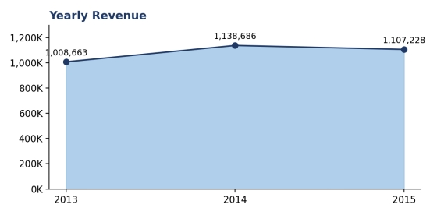
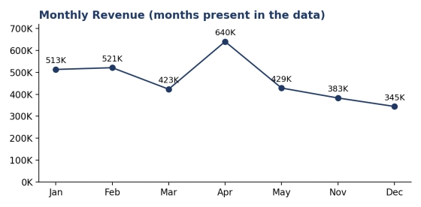
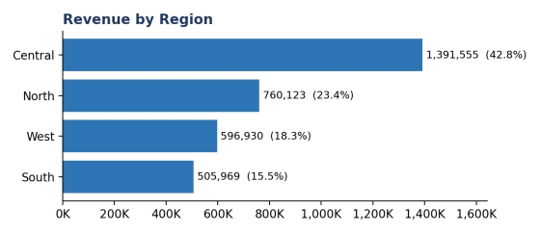
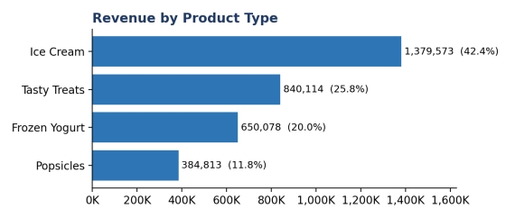
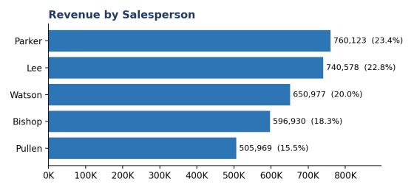

Dashboard
This section reviews the dashboard sheet itself: how it is laid out, what each element communicates, how the filters behave, and where the design could be improved. The sheet is titled “Salespersons Performance Dashboard” and is built to be read on a single screen, with gridlines and row and column headers hidden for a clean look.
The dashboard page
This shows the dashboard as a manager sees it. The title banner and the three KPI cards sit at the top, the two trend charts follow, the three comparison charts run along the bottom, and the four slicers sit on the right-hand side.
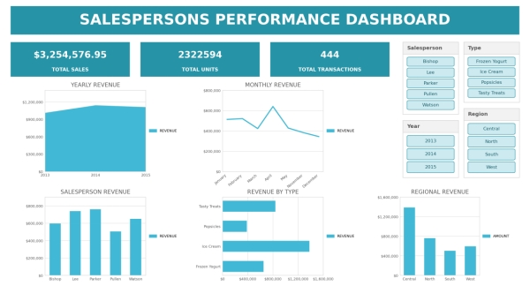
Layout
Zone | Content | Position on the sheet
Title banner | Dashboard title in white text on a teal band | Across the full width, at the top
KPI cards | Total Sales, Total Units, Total Transactions | Directly under the title
Trend charts | Yearly Revenue (area) and Monthly Revenue (line) | Upper row, left and centre
Comparison charts | Salesperson Revenue (column), Revenue by Type (horizontal bar), Regional Revenue (column) | Lower row, left to right
Filters | Four slicers: Salesperson, Year, Type and Region | Right-hand side, beside and above the charts
The reading order is natural: the overall result first, then the trend over time, then the comparisons between groups. A single teal colour is used throughout, which keeps the page consistent and uncluttered.
Key performance indicators (KPIs)
Three KPI cards sit directly under the title and give the scale of the business before any chart is read. They are shown in Figure 2 and explained in Table 10.
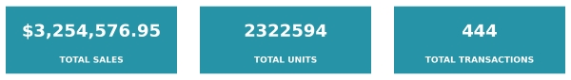 The three KPI cards
KPI card | Value | Formula in the workbook | What it measures
Total Sales | $3,254,576.95 | =SUM(sales[Sales]) | Total value of all orders from 2013 to 2015.
Total Units | 2,322,594 | =SUM(sales[Units]) | Total number of units sold.
Total Transactions | 444 | =COUNTA(sales[Order #]) | Number of order lines recorded.

Several useful measures can be derived from these three cards, and they help in judging the size of a typical order.
Derived KPI | Value | Calculation
Average sales per transaction | $7,330.13 | Total Sales ÷ Total Transactions
Average units per transaction | 5,231 | Total Units ÷ Total Transactions
Average price per unit | $1.40 | Total Sales ÷ Total Units
Two points about the cards should be noted. First, they read directly from the data table instead of the PivotTables, so they do not change when a slicer is used. Second, Total Sales is shown as currency with two decimals, while Total Units and Total Transactions are shown as plain numbers, so Total Units appears as 2322594 without thousands separators.
What each chart shows
Chart | Type | Wh dashboard tells the reader
Yearly Revenue | Area | Revenue rises from about $1.01 million in 2013 to $1.14 million in 2014, then eases to $1.11 million in 2015. The shape shows growth followed by a plateau.
Monthly Revenue | Line | April is the clear peak at about $640,000. January and February are also strong, while November and December are the lowest points.
Salesperson Revenue | Column | Parker and Lee stand highest, Watson and Bishop sit in the middle, and Pullen is lowest.
Revenue by Type | Horizontal bar | Ice Cream has the longest bar by a wide margin, followed by Tasty Treats, Frozen Yogurt and Popsicles.
Regional Revenue | Column | Central is far taller than North, West and South, which are close to one another.

Interactivity
All four slicers (Year, Type, Salesperson and Region) are connected to all five PivotTables behind the charts. A single click therefore re-filters every chart at the same time. Useful ways to use this include:
- selecting a single year to compare the mix of products and regions year by year;
- selecting a product type, such as Popsicles, to see which regions and salespeople sell it most; and
- selecting a region to see its salespeople. Because each salesperson works in only one region, choosing Parker leaves only the North region, and choosing Central leaves only Lee and Watson.
One important limitation applies. The three KPI cards read directly from the data table, not from the PivotTables, so they do not respond to the slicers. If a user filters to Ice Cream, the charts change but the cards continue to show the full totals of $3,254,576.95, 2,322,594 units and 444 transactions. This can be misleading because the cards appear to describe the filtered view.
Design review
What works well
- A clean, one-page layout with a clear title, a KPI strip and logically grouped charts.
- A consistent colour scheme and hidden gridlines that keep attention on the data.
- Slicers connected to every chart, which makes exploration fast and consistent.
- Charts that pair sensibly with the question: area and line for change over time, bars and columns for comparisons between groups.
What could be improved
- Title typo. The banner reads “SALESPERSONS PERFOMANCE DASHBOARD”; “PERFOMANCE” should be “PERFORMANCE”.
- KPI cards are not linked to the slicers. As they always show overall totals.
- Inconsistent number formats. Total Sales is shown as currency, but Total Units (2322594) has no thousands separator, so it is harder to read at a glance.
- Cluttered axes and no data labels. The value axes display full currency with two decimals (for example, $3,500,000.00), and the bars carry no labels, so exact values cannot be read without hovering. Showing values in thousands or millions, with data labels, would be cleaner.
- Redundant legends. Each chart has only one series, so the legend repeats what the chart title already says and takes up space.
- Alphabetical ordering. Salespeople, product types and regions are listed alphabetically instead of by value, so the ranking is not immediately obvious. Sorting from highest to lowest would help.
- Missing months are not signalled. The monthly line runs from January to May and then November and December, with nothing to show that June to October are absent from the data. A reader could assume the year is complete.
- Chart type for yearly data. An area chart suggests continuous data, but there are only three yearly points. A simple column chart would represent them more precisely.

Findings
- Growth has levelled off. Revenue increased by 12.9% in 2014 but declined by 2.8% in 2015. Total units were the same in each year.
- Ice Cream drives the business. At $1,379,573.20 it is more than one and a half times the size of the next product, Tasty Treats, and accounts for 42.4% of revenue.
- Popsicles are the smallest line. They contribute only 11.8% of revenue and have the lowest average order value ($5,345), although they showed the fastest growth between 2013 and 2015 (+12.1%).
- Central dominates regionally. It earns 42.8% of revenue and the highest average per order ($8,283). Part of this advantage comes from having two salespeople, Lee and Watson.
- South is the weakest region. With 15.5% of revenue and the lowest average order value ($6,023), it has the clearest room to improve. It was, however, the fastest-growing region between 2013 and 2015 (+12.3%).
- Individual performance differs sharply. Parker and Lee together bring in 46.2% of all sales. Pullen is lowest at $505,968.95, and Bishop is also below the average of the five salespeople ($650,915).
- Sales are seasonal. April is the peak month in all three years, and the first five months of the year account for 77.6% of the revenue recorded. November and December are the weakest.
- Product mix varies by region. For example, Tasty Treats makes up only about 17% of South’s revenue, compared with 28% in Central, which points to uneven product coverage.

Recommendations
- Protect and grow Ice Cream. Because it carries over 40% of revenue, make sure supply, pricing and promotions for Ice Cream are secure, especially in the peak months.
- Plan around the seasonal peak. Build stock and staffing plans around April and the January to May period, and design targeted promotions to lift sales in November and December.
- Support the South and West regions. Review territory size, customer coverage and product availability in South and West, and introduce stronger Tasty Treats and Frozen Yogurt offerings where the product mix is thin.
- Learn from the best performers. Study what Parker and Lee do differently, and what Watson does to achieve the highest value per order, and share these practices through coaching and sales targets.
- Investigate the 2015 slowdown. Confirm whether the dip reflects pricing, competition or customer demand, and set growth targets for 2016 that are tied to the findings.
- Strengthen data quality. Confirm whether the near-identical records are genuine, replace manually typed Sales values with a documented pricing rule, and collect data for every month of the year.
- Extend the dashboard. Add profit margin, cost and customer data, and include a date field so that trends can be tracked automatically.

Limitations
- Incomplete months. Only seven months (January to May, November and December) are in the data. June to October are missing, so annual totals and seasonal conclusions cover only part of the year.
- Possible duplicate records. 218 records match another record in every field except Order #. If these are accidental duplicates, sales, units and transactions would be overstated by up to about half. This needs confirmation from the data owner.
- Identical units each year. Total units are exactly 774,198 in 2013, 2014 and 2015. This is unusual for real sales data and may indicate that the data is simulated or was copied across years.
- Manually adjusted Sales values. Most Sales values come from Units multiplied by a fixed rate, and a few typed values do not follow those rates. Revenue therefore reflects an assumed price, not necessarily the actual invoiced amount.
- Revenue only. There is no cost, discount, profit or customer information, so the analysis cannot measure profitability or customer behaviour.
- Region and salesperson overlap. Each salesperson works in a single region, so the effect of the region cannot be separated from the effect of the individual.
- Short time span. Three years is a limited basis for judging long-term trends, and a single year-on-year decline does not by itself establish a downward trend.
- Descriptive analysis only. The work describes what happened but does not explain why, and does not forecast future sales.

Conclusion
This project successfully converted a flat list of 444 order records into a structured, filterable dashboard that answers the main questions managers ask about sales. The results show a business with total sales of $3,254,576.95, led by Ice Cream and the Central region, with a clear seasonal peak in April and noticeable differences in performance between salespeople.
Revenue growth that was strong in 2014 did not continue in 2015, so attention should now move from simply recording sales to understanding what will restart growth. The dashboard provides the foundation for that work.
The findings should be treated with appropriate care until the data quality points raised in this document have been confirmed, especially the near-identical order lines and the missing months. Once these are resolved, the same workbook can be refreshed and extended to give management a dependable, ongoing view of performance.

